# Project - Engineering Full Stack Apps in the Cloud

## Engineering Process and Quality

1. GitHub Repository :- <https://github.com/anmolaggarwal21/cloud-developer>

As mentioned, the code is in Master branch. Under this please take the project under course-02 🡪 image-filter-starter-code.

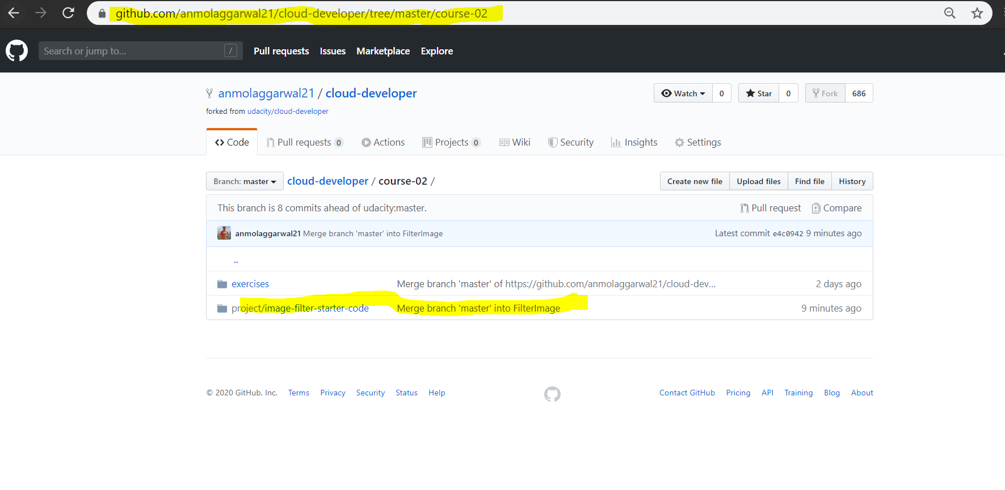

1. Have used proper naming convention as well as sending an error message when we enter an invalid image URL

## Development Server

Npm run dev ran successfully, as well as, the stubbed method is completed successfully. Please find below the image where the server is running on localhost with port 8082, and we are able to consume the filteredimage end point

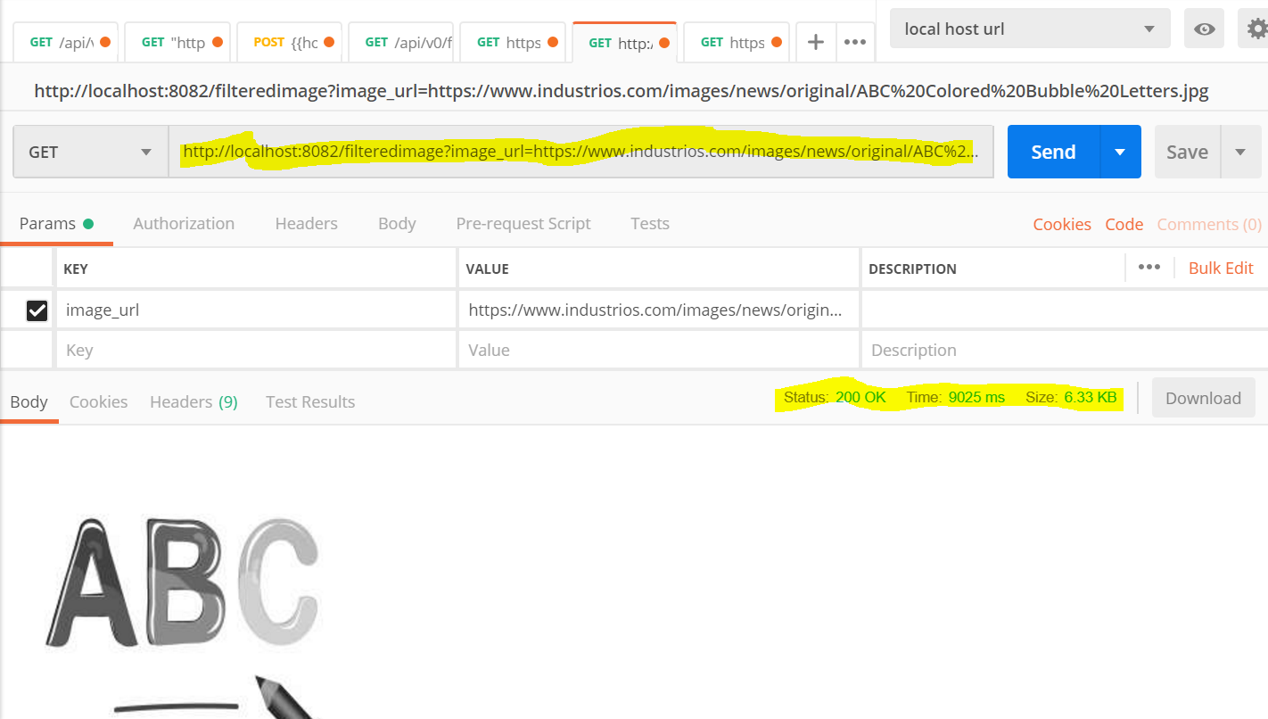

Error of 422, when we have an invalid url.

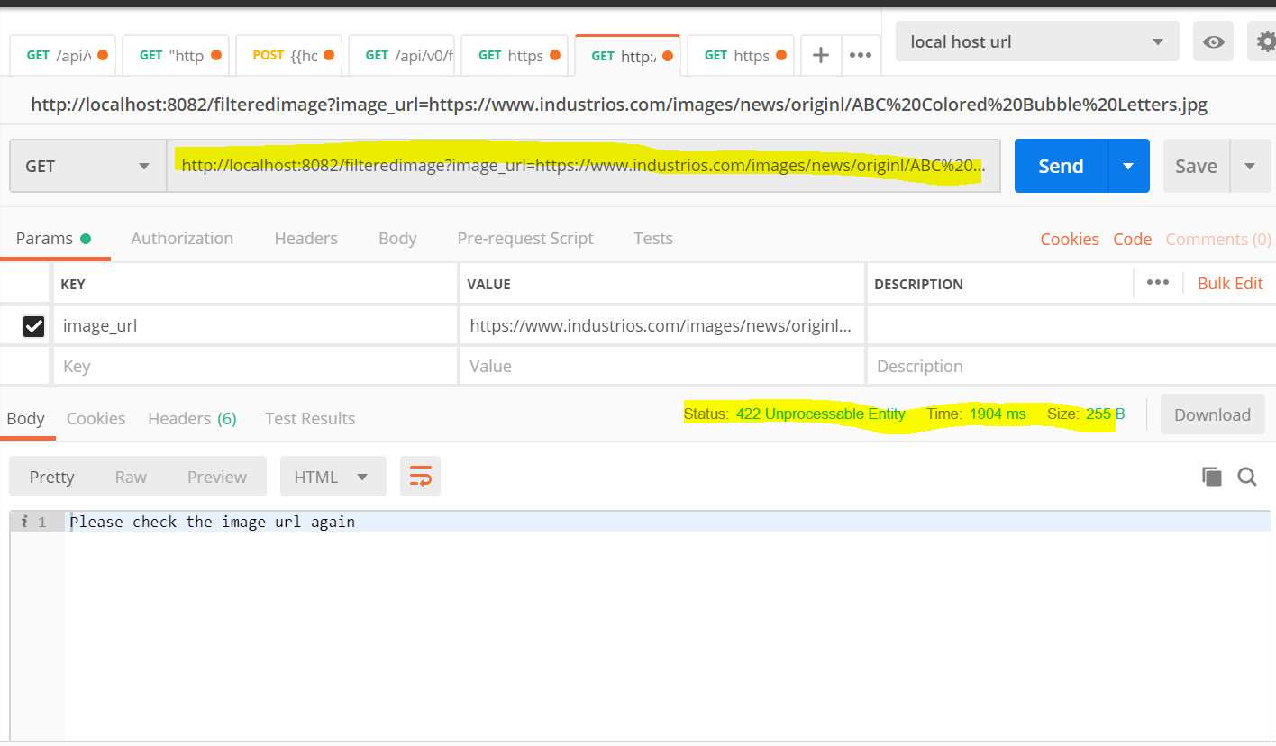

## Elastic Beanstalk Deployment

screenshot of the elastic beanstalk application dashboard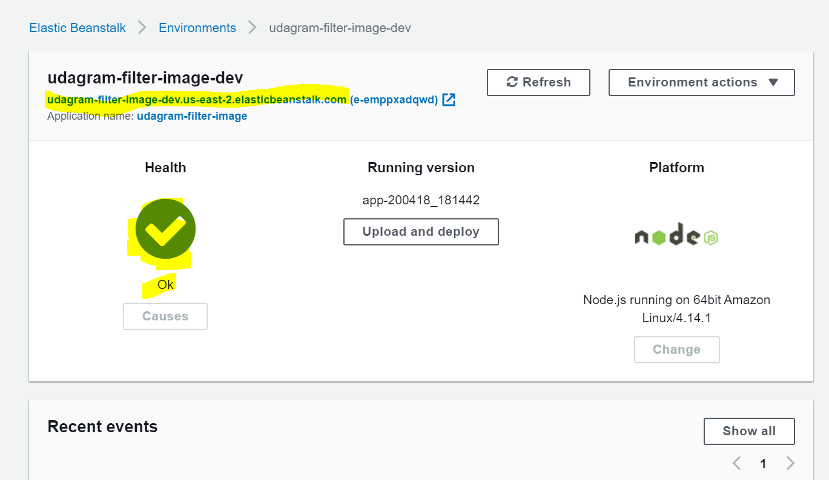

An endpoint URL for a running elastic beanstalk deployment (EB_URL) has been submitted along with the project submission. This endpoint responds to valid GET requests including

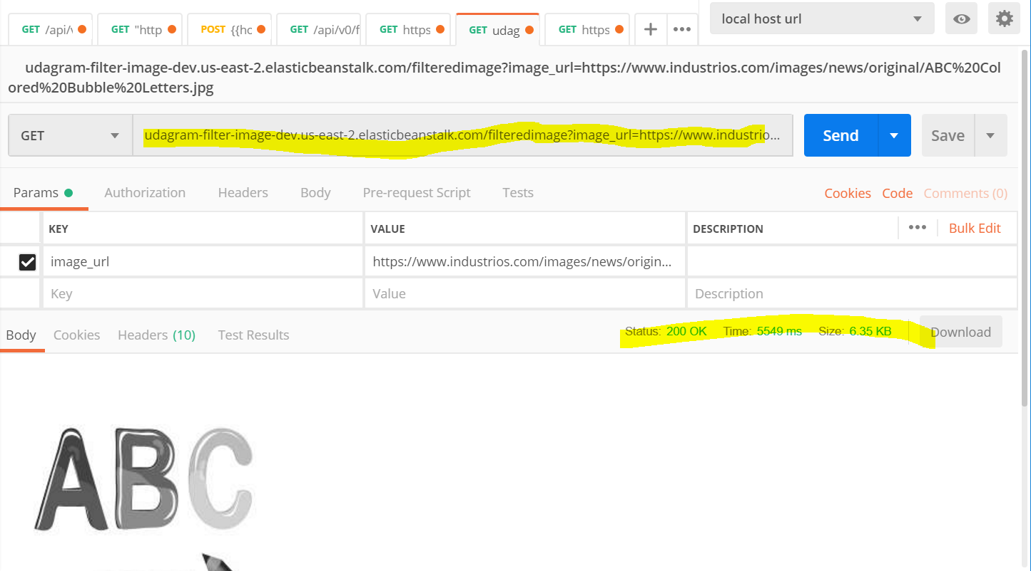

With error

